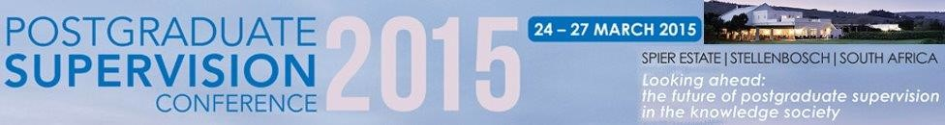

**FIFTH BIENNIAL CONFERENCE ON RESEARCH INTO POSTGRADUATE**

**SUPERVISION**

**ANNOUNCEMENT**

**Looking ahead: the future of postgraduate supervision in the knowledge society**

Centre for Higher and Adult Education

Stellenbosch University, South Africa, 25-27 March 2015

# Background

The Centre for Higher and Adult Education (CHAE) at Stellenbosch University held its first international conference on postgraduate supervision in April 2007 with the theme *Postgraduate Supervision: State of the art and the artists.* Since then three more conferences were held, in 2009 on *Postgraduate Supervision Research and Practice*, in 2011 on *Promoting a culture of postgraduate scholarship* and most recently in 2013 on *Candidates, supervisors and institutions: pushing postgraduate boundaries*. Building on this experience, we are delighted to invite our wide network of international and national conference participants to the fifth Postgraduate Supervision Conference in 2015.

# Postgraduate Supervision Conference 2015: 25-27 March 2015

In 2015 the fifth Postgraduate Supervision conference will once again be hosted at the beautiful Spier Wine Estate and Conference Centre just outside the university town of Stellenbosch. For this conference we shall focus our discussions on the future of postgraduate studies and supervision, particularly in the context of the knowledge society, under the theme: **Looking ahead: the future of postgraduate supervision in the knowledge society.** The conference opens on Wednesday 25 March 2015 and closes at lunchtime on Friday 27 March 2015. On Tuesday 24 March 2014 we shall present six halfday workshops for which conference participants can register separately.

# Important dates

First call for abstracts: 30 April 2014

Submission date for abstracts: 29 August 2014

Feedback to authors of abstracts: 26 September 2014

Final submission date for amended abstracts: 24 October 2014

Closing date for registration: 26 January 2015

Final date for late registration: 3 March 2015

Submission of full papers (for conference publication): 8 April 2016

1

# Conference theme: Looking ahead: the future of postgraduate supervision in the knowledge society

*Track 1: Higher education systemic and/or institutional change in the context of the knowledge society and its implications for postgraduate supervision*

*Track 2: Opportunities and challenges for postgraduate studies afforded by the knowledge society*

*Track 3: Innovations in postgraduate supervision to meet the needs of the knowledge society*

*Track 4: Changing expectations of postgraduate students who live and work in the knowledge society*

**Individual or joint papers** on the development of theory, completed research or research in progress within any of these tracks are most welcome. For the first time the 2015 conference will make space for the **postgraduate student voice** in a special track. Although Track 4 is open for contributions from supervisors and researchers, we anticipate that this track will particularly attract contributions from postgraduate students.

Keynote speakers:

Pam Denicolo, University of Surrey, United Kingdom:

*International Developments in the Purpose and Process of the Doctorate: Consequences for Supervision, Examining and the Employment of Graduates*

Anthony Paré, University of British Columbia, Canada:

*A new rhetoric for the knowledge society: implications for doctoral students and supervisors*

Johann Mouton, Stellenbosch University, South Africa:

*The doctorate in South Africa: current debates and future challenges*

Michael Samuel, University of Kwazulu-Natal, South Africa:

*The future of doctoral education*

# Conference venue

The conference will convene at Spier Estate, Stellenbosch. Stellenbosch is a scenic university town situated in the Winelands of the Western Cape. Magnificent natural surroundings, graceful architecture and the inherent elegance of Spier make it the perfect venue to host the Postgraduate Supervision 2015 Conference. Please visit the Spier website at www.spier.co.za should you want more information on the venue.

# Travel information

Cape Town International Airport is located 30 minutes’ drive from Stellenbosch. Most international flights connect to Cape Town via O.R. Tambo International Airport in Johannesburg, although a number of direct flights from Europe are also available.

# Conference website

Please visit the confererence website (www.postgraduate2015.co.za) for more information on the conference theme, tracks, workshops, keynote speakers, accommodation options, etc.

2